

**BUSSELTON SENIOR HIGH SCHOOL**

**Semester 2 Examination**

**2017**

**CHEMISTRY**

**Units 3 & 4**

Student Name _________________________________

***TIME ALLOWED FOR THIS PAPER***

Reading time before commencing work: Ten minutes

Working time for the paper: Three hours

**MATERIALS REQUIRED/RECOMMENDED FOR THIS PAPER**

**To be provided by the supervisor:**

This Question/Answer Booklet

Multiple-choice Answer Sheet

Chemistry Data Book

**To be provided by the candidate:**

Standard items: pens (blue/black preferred), pencils (including coloured), sharpener,

eraser, correction tape/fluid, ruler, highlighters

Special items: up to three non-programmable calculators approved for use in the WACE examinations

**IMPORTANT NOTE TO CANDIDATES**

No other items may be taken into the examination room. It is **your** responsibility to ensure that you do not have any unauthorised notes or other items of a non-personal nature in the examination room. If you have any unauthorised material with you, hand it to the supervisor **before** reading any further.

**Structure of this paper**

|  |  |  |  |  |  |
| --- | --- | --- | --- | --- | --- |
| Section | Number of questions available | Number of questions to be answered | Suggested working time  (minutes) | Marks available | Percentage of exam |
| Section One:  Multiple-choice | 25 | 25 | 50 | /50 | /25 |
| Section Two:  Short answer | 8 | 8 | 60 | /70 | /35 |
| Section Three:  Extended answer | 5 | 5 | 70 | /80 | /40 |
|  | | | | | /100 |

**Instructions to candidates**

1. Answer the questions according to the following instructions.

Section One: Answer all questions on the separate Multiple-choice Answer Sheet provided. For each questions shade the box to indicate your answer. Use only a blue or black pen to shade the boxes. If you make a mistake, place a cross through that square then shade your new answer. Do not erase or use correction fluid/tape. Marks will not be deducted for incorrect answers. No marks will be given if more than one answer is completed for any question.

Sections Two and Three: Write your answers in this Question/Answer Booklet.

2. When calculating numerical answers, show your working or reasoning clearly. Express numerical answers to the appropriate number of significant figures and include appropriate units where applicable.

3. You must be careful to confine your responses to the specific questions asked and to follow any instructions that are specific to a particular question.

4. Spare pages are included at the end of this booklet. They can be used for planning your responses and/or as additional space if required to continue an answer.

* + Planning: If you use the spare pages for planning, indicate this clearly at the top of the page.
  + Continuing an answer: If you need to use the space to continue an answer, indicate in the original answer space where the answer is continued, i.e. give the page number. Fill in the number of the question(s) that you are continuing to answer at the top of the page.

5. The Chemistry Data Book is **not** handed in with your Question/Answer Booklet.

**Section One: Multiple-choice 25% (50 marks)**

This section has **25** questions. Answer **all** questions on the separate Multiple-choice Answer Sheet provided. For each question, shade the box to indicate your answer. Use only a blue or black pen to shade the boxes. If you make a mistake, place a cross through that square then shade your new answer. Do not erase or use correction fluid/tape. Marks will not be deducted for incorrect answers. No marks will be given if more than one answer is completed for any question.

Suggested working time: 50 minutes.

1. What type of reaction is represented by the conversion of butan-1-ol to butanoic acid?

(a) Addition

(b) Hydrolysis

(c) Oxidation

(d) Substitution

2.Consider the following system, which is at equilibrium.

Ag+(aq) + Br –(aq) $⇌$ AgBr(s) + heat

Which one of the following changes would cause a decrease in the concentration of silver ions, as the system re-establishes equilibrium?

(a) Cooling the system.

(b) Placing the system under higher pressure.

(c) Stirring the equilibrium mixture.

(d) Adding solid silver bromide to the system.

3. An organic substance has an empirical formula of C3H6O2. Which of the following is NOT a possible identity of the substance?

(a) Propanoic acid

(b) Ethyl methanoate

(c) Methyl methanoate

(d) Methyl ethanoate

4. Which of the following statement about the primary structure of proteins is correct?

1. They exhibit mainly hydrogen bonding within their structure.
2. They have been isolated from the same species of living organisms.
3. They have a specific sequence of amino acids.
4. They perform a similar function

5. Which one of the following 1.0 mol L–1 solutions will have the lowest pH?

1. Sodium ethanoate
2. Potassium chloride
3. Ammonium chloride
4. Sodium phosphate

6. In which one of the following reactions is the underlined species acting as a

Br**∅**nsted-Lowry acid?

(a) KHCO3(s) + H+(aq) → K+(aq) + H2O(ℓ) + CO2(g)

(b) H2CO3(aq) + NaOH NaHCO3(aq) + H2O(ℓ)

(c) CO2(g) + H2O(ℓ) H2CO3(aq)

(d) CO32–(aq) + Ca2+(aq) → CaCO3(s)

7. Ocean acidification has become a modern day global concern for all of humanity. It is thought to be the direct result of increased levels of carbon dioxide in the atmosphere. Which of the following reasons is **least** likely a justification for this phenomenon?

1. Rising global temperatures.
2. Increasing emissions from vehicles.
3. Continual and increasing usage of fossil fuels.
4. Increasing global population.

8. Which of the following combinations can be used to form a buffer solution?

1. NH3(aq) / NH4Cℓ(aq)
2. HCℓ(aq) / NaCℓ(aq)
3. HCℓ(aq) / NH4Cℓ(aq)
4. H2PO4–(aq) / HPO42–(aq)
5. H2SO4(aq) / HSO4–(aq)
6. **i** and **iv** only
7. **i, iv** and **v** only
8. **i, ii** and **iv** only
9. **iv** only

9. Water can undergo self-ionisation according to the following reaction.

2 H2O(ℓ) OH–(aq) + H3O+(aq)

For pure water at 25 oC, the hydrogen ion (H+) concentration is 1.0 x 10–7 mol L–1 and the pH is 7.0. When the temperature is lowered, the pH of the water is observed to rise. Which of the following statements gives the best explanation for this observation?

(a) The forward reaction is exothermic.

(b) The concentration of OH–(aq) reduces, thus decreasing its acidity.

(c) The water is no longer neutral, so the pH of water increases.

(d) The concentration of the H3O+(aq) decreases.

10. Consider the short section of the polymer below.

CH3 Cℓ CH3 Cℓ

---------- C C C C ----------

H Cℓ H Cℓ

Which one of the following is the **correct** name for the monomer used to synthesise this polymer?

(a) 2,2-dichlorobut-1-ene

(b) 1,1-dichlorobut-2-ene

(c) 1,1-dichloro-2-methylethene

(d) 1,1-dichloropropene

11. Increasing carbon dioxide levels in the atmosphere cause the concentration of carbonic acid, H2CO3,to increase in the ocean. For which of the following aqueous species found in ocean water, does this cause an increased concentration?

* 1. OH–(aq)
  2. HCO3–(aq)
  3. H3O+(aq)
  4. Ca2+(aq)

1. **i** only.
2. **i, ii** and **iii**
3. **ii** and **iii**
4. All of them.

12. In which of the following processes is bromine being reduced?

1. PBr3 + Br2 → PBr5
2. Br2 + H2O → Br– + HBrO + H+
3. 2 Br– → Br2 + 2 e–
4. HBrO3 + H2O2 → HBrO4 + H2O
5. **i, ii** and **iv** only
6. **ii, iii** and **iv** only
7. **i**, and **ii** only
8. **i** and **iv** only

**Questions 13 and 14 relate to the following diagram**

The following electrolytic cell was set up as shown.

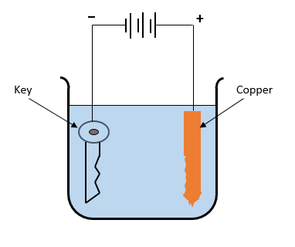

13. Which of the following statements about the cell is **correct**?

(a) The key becomes the anode when the cell is operating.

(b) The key will gradually lose mass as the electrolysis process continues over an extended period of time.

(c) The cathode is the copper rod.

(d) The purpose of the anode is to replenish and maintain a steady supply of cations in the solution.

14. Which one of the following statements is **false**?

(a) Oxidation occurs at the copper electrode.

(b) The purpose of the battery is to provide a flow of electrons from anode to cathode.

(c) Cations move through the solution from the cathode to the anode.

(d) Reduction occurs at the site where electrons are made available.

15. Use the table of standard reduction potentials to determine which of the following reactions are likely to occur spontaneously under standard conditions.

* 1. H2(g) + Br2(aq) → 2 Br –(aq) + 2 H+(aq)
  2. Cu(s)  + 2 H+(aq) → Cu2+(aq) + H2(aq)
  3. Sn(s)  + Cd2+(aq) → Sn2+(aq) + Cd(s)
  4. H2O2(aq) + Zn2+(aq) → O2(g)+ 2 H+(aq) + Zn(s)

1. **i** and **iv** only
2. **i** only
3. **iii** and **iv**
4. **iv** only

**Question 16, 17 and 18 relate to the following information**

A methanol-air battery is a special fuel cell that involves methanol reacting directly with oxygen from the air. The relevant half-equations are shown below.

O2(g) + 2 H2O(ℓ) + 4 e– 4 OH–(aq) E0 = +0.40 V

CO2(g) + 6 H+(aq) + 6 e– CH3OH(ℓ) + H2O (ℓ) E0 = -1.10 V

16. Which one of the following reasons **best** explains why this cell is described as a fuel cell?

1. It is an efficient and reliable energy source that can be used to replace fossil fuels.
2. It can be recharged as both half-reactions are easily reversible.
3. It requires the reactants to be continuously supplied to the cell during operation.
4. It requires that one of the reactants to be a liquid and the other to be a gas for optimal operation.

17. Which one of the following is the overall equation for the cell?

1. O2(g) + 2 H2O(ℓ) → 4 OH–(aq) + 2 O2– (aq)
2. 2 CH3OH(ℓ) + 4 H2O (ℓ) → 16 OH–(aq) + 2 CO2 (g)
3. 4 H2O(ℓ) + 2 CO2(g) → 3 O2(g) + 2 CH3OH(ℓ)
4. 3 O2(g) + 2 CH3OH(ℓ) → 4 H2O(ℓ) + 2 CO2(g)

18. The theoretical voltage obtainable from this cell under standard conditions is:

(a) 1.10 V.

(b) 1.50 V.

(c) 0.30 V.

(d) 0.70 V.

19. The following two organic substances were reacted together under favourable conditions and a new product was formed.

HOOC – (CH2)3 – COOH and CH3 – CH – CH2 – CH2 – OH

OH

Which one of the following could be produced from this reaction?

1. A protein
2. A fatty acid
3. A soap
4. A polyester

20. Which of the following pairs of compounds would form ethyl butanoate when warmed with concentrated sulfuric acid?

(a) CH3CH2OH and CH3CH2COOH

(b) CH3CH3CH3CH2OH and CH3COOH

(c) CH3CH2CH2COOH and CH3CH2OH

(d) CH3COOH and CH3CH2CH2OH

21. Consider the two α-amino acids, **X** and **Y**, shown below.

**X** **Y**

CH2OH O O

H2N CH C H2N CH(CH3) C

OH OH

The correct names for these two α-amino acids are:

(a) alanine and valine respectively.

(b) valine and threonine respectively.

(c) serine and alanine respectively.

(d) serine and lysine respectively.

22. An energy profile diagram for a chemical reaction is shown below.

Energy 500

(kJ mol L-1)

400

300

200

100

Progress of reaction

The reaction is:

(a) Exothermic with an activation energy of +400 kJ mol L-1

1. Endothermic with an activation energy of +250 kJ mol L-1

(c) Exothermic with an enthalpy change of +150 kJ mol L-1

(d) Endothermic with an enthalpy change of +150 kJ mol L-1

**Questions 23 and 24 relate to the compounds shown below**

O

1. COOH **ii.** CH3CH2CCH2CH3

**iii.** CH3CH2COO **iv.** CH3CH2CHO

23. Which one of the following lists places the compounds in their correct class?

1. **ii iii iv**
2. Ester Aldehyde Ketone Carboxylic acid
3. Carboxylic acid Ketone Ester Aldehyde
4. Carboxylic acid Ester Ketone Aldehyde
5. Aldehyde Ketone Carboxylic acid Ester

24. Which of the compounds shown above can be identified by using litmus paper alone?

1. **i** and **iv**
2. **i** and **ii**
3. **ii** and **iii**
4. **i** only.

25. An enzyme is a biological catalyst. An esterase enzyme can be used in the hydrolysis of an ester as shown below.

esterase

ester + water $⇌$ carboxylic acid + alcohol

Upon the addition of esterase, which of the following statement is **correct** for this process?

1. The position of equilibrium for this reaction is shifted to the right.
2. The rates of the forward and reverse reactions both increase equally.
3. The rate of the forward reaction increases more than the rate of the reverse reaction.
4. The rate of the forward reaction increases while the rate of the reverse reaction decreases.

**End of Section One**

**Section Two: Short answer 35% (70 marks)**

This section has **eight (8)** questions. Answer **all** questions. Write your answers in the spaces provided.

When calculating numerical answers, show your working or reasoning clearly. Express numerical answers to the appropriate number of significant figures and include appropriate units where applicable.

Spare pages are included at the end of this booklet. They can be used for planning your responses and/or as additional space if required to continue an answer.

* Planning: If you use the spare pages for planning, indicate this clearly at the top of the page.
* Continuing an answer: If you need to use the space to continue an answer, indicate in the original answer space where the answer is continued, i.e. give the page number. Fill in the number of the question(s) that you are continuing to answer at the top of the page.

Suggested working time: 60 minutes.

**Question 26 (7 marks)**

Nitrosyl bromide (NOBr2) decomposes and reaches equilibrium according to the equation below.

2NOBr2(g) 2NO(g) + Br2(g) ΔH< 0

1. Write the equilibrium constant expression for this reaction. (1 mark)

________________________________________________________________________

1. A number of changes were imposed on the equilibrium mixture, as described in (i) and (ii) below. Show the effects of these changes by extending the lines accordingly on the diagram shown, as the system re-establishes a new equilibrium in each case.
   * 1. A quantity of NOBr2 was introduced into the vessel at time **t1**, at constant temperature. (3 marks)
     2. At time **t2**, the temperature in the reaction vessel was increased. (3 marks)

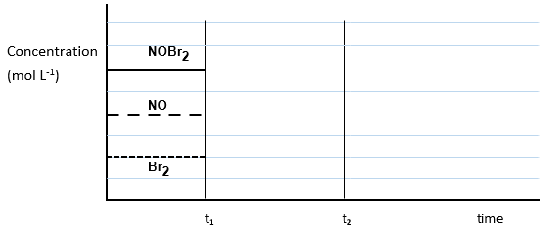

**Question 27 (12 marks)**

(a) Calculate the pH of a solution of 0.250 mol L–1 nitric acid. (2 marks)

__________________________________________________________________________

__________________________________________________________________________

__________________________________________________________________________

(b) A student was asked to dilute 25.0 mL of this solution to produce a solution of nitric acid with a pH of 1.50. Calculate the volume of distilled water that she would need to add. (4 marks)

__________________________________________________________________________

__________________________________________________________________________

__________________________________________________________________________

__________________________________________________________________________

__________________________________________________________________________

__________________________________________________________________________

1. Another 25.0 mL sample of the original nitric acid solution was combined with 1.30 g of potassium hydroxide. Calculate the pH of the final mixture. (Assume no change to the volume).

(6 marks)

__________________________________________________________________________

__________________________________________________________________________

__________________________________________________________________________

__________________________________________________________________________

__________________________________________________________________________

__________________________________________________________________________

__________________________________________________________________________

__________________________________________________________________________

__________________________________________________________________________

__________________________________________________________________________

__________________________________________________________________________

__________________________________________________________________________

__________________________________________________________________________

**Question 28 (11 marks)**

Examine the following polypeptide structure.

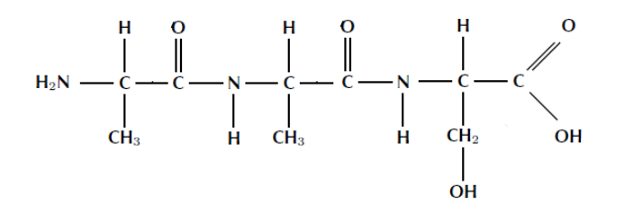

(a) With reference to the structure shown above, complete the primary sequence of the amino acids in the spaces below using the standard three letter abbreviations, as given on the Chemistry Data Booklet. (One is done for you).

(2 marks)

ala – _________ – __________

(b) With reference to relevant sections of the same structure shown above, describe what is meant by a peptide bond.

(1 mark)

________________________________________________________________________

________________________________________________________________________

________________________________________________________________________

________________________________________________________________________

Valine is another amino acid which is commonly found in a range of different polypeptides.

Like most amino acids, valine is able to self-ionise and produce a specialised structure called a zwitterion.

(c) Draw a diagram of valine in zwitterion form in the space below. (2 marks)

(d) Making reference to the structure you have drawn above and with the aid of a relevant chemical equation, explain how the zwitterion is able to resist changes in pH when a small amount of **base** is introduced.

(3 marks)

________________________________________________________________________

________________________________________________________________________

________________________________________________________________________

________________________________________________________________________

________________________________________________________________________

________________________________________________________________________

________________________________________________________________________

(e) Medical researchers are able to alter the primary sequence of amino acids in a protein and thus produce changes in their secondary and tertiary structures. Use relevant chemical theory to explain how these changes are produced and what effect they will have on the secondary and tertiary structures. (3 marks)

________________________________________________________________________

________________________________________________________________________

________________________________________________________________________

________________________________________________________________________

________________________________________________________________________

________________________________________________________________________

________________________________________________________________________

________________________________________________________________________

________________________________________________________________________

________________________________________________________________________

**Question 29 (6 marks)**

A newly discovered plant dye called kalanolein, can be used in biological laboratories to culture yeasts for home brewing kits. It has also been found that this same dye can be used for acid-base titrations as it displays two colours, orange and purple, as shown in the diagram below.

pH 0 1 2 3 4 5 6 7 8 9 10 11 12 13 14

|  |  |
| --- | --- |
| orange | purple |

A few drops of kalanolein were added to separate aqueous solutions of sodium hydrogencarbonate, (NaHCO3) and ammonium chloride, (NH4Cℓ).

* + 1. In the space below, write a balanced hydrolysis equation for each substance listed and also state the colour that would be observed in each case. (4 marks)

NaHCO3 (aq)

________________________________________________________________________

________________________________________________________________________

Colour __________________________

NH4Cℓ (aq)

________________________________________________________________________

________________________________________________________________________

Colour __________________________

A typical acid/base titration between a standardised solution of sodium hydroxide, NaOH(aq) and an unknown solution of ethanoic acid, CH3COOH(aq) was to be carried out, using common laboratory equipment.

(b) Using relevant chemical theory, explain whether kalanolein would be a suitable indicator for this titration? (2 marks)

________________________________________________________________________

________________________________________________________________________

________________________________________________________________________

________________________________________________________________________

________________________________________________________________________

**Question 30 (7 marks)**

Aluminium is refined in a two-part process from the mineral ‘bauxite’ and extracted directly from alumina, (Aℓ2O3) using electrorefining processes. Aluminium is used to make many different alloys due to its corrosion resistance, as well as finding application in the building industry and aviation, due to its light-weight and relatively strong properties.

A student was given the following sets of aqueous 1.00 mol L–1 solutions and asked to find out whether any of them could be safely stored in an aluminium cup.

The solutions were: Fe(NO3)2, Mg(NO3)2, Cu(NO3)2 and Ni(NO3)2

(a) Using relevant chemical equations, explain which of the solutions could be safely stored in a cup made of aluminium metal.

(4 marks)

________________________________________________________________________

________________________________________________________________________

________________________________________________________________________

________________________________________________________________________

________________________________________________________________________

________________________________________________________________________

________________________________________________________________________

________________________________________________________________________

________________________________________________________________________

When aluminium metal is placed in an acidified solution of sodium hydrogendichromate, (containing the weakly acidic ion, hydrogendichromate (HCr2O7–), a deep green solution containing chromium (III) ions is formed, and the aluminium metal dissolves producing aluminium ions.

(b) In the space below, write separate oxidation and reduction half-equations, and then the overall redox equation for this reaction. (3 marks)

________________________________________________________________________

________________________________________________________________________

________________________________________________________________________

________________________________________________________________________

________________________________________________________________________

**Question 31 (8 marks)**

Sodium hypochlorite (NaCℓO) is commonly used in the textile industry as a bleach. When added to water, hypochlorous acid (HCℓO) is formed. The solution can now be considered as an equilibrium system, where hypochlorite ions are converted into hypochlorous acid.

CℓO–(aq) + H2O(ℓ) HCℓO(aq) + OH–(aq) + HEAT

1. Complete the following table by predicting, with reasoning, the effect that the following changes will have on the concentration of the hypochlorous acid (HCℓO) in the treated water. (4 marks)

|  |  |  |
| --- | --- | --- |
| **Imposed change** | **Predicted effect to the concentration of HCℓO(aq)** | **Brief justification for your prediction** |
| Addition of some hydrochloric acid to the water |  |  |
| Increasing the temperature of the water |  |  |

(b) A 1 500 L tank needs to be filled with treated water that has a concentration of 1.75 ppm of hypochlorous acid. Calculate the mass of sodium hypochlorite that would be required to provide this level of hypochlorous acid, assuming that 65% conversion of sodium hypochlorite to hypochlorous acid will take place.

(Assume 1.00 L of the treated water has a mass of 1.00 kg) (4 marks)

__________________________________________________________________________

__________________________________________________________________________

__________________________________________________________________________

__________________________________________________________________________

__________________________________________________________________________

__________________________________________________________________________

__________________________________________________________________________

__________________________________________________________________________

**Question 32 (8 marks)**

Propan-2-ol can be readily oxidised using an acidified potassium permanganate solution.

(a) In the space below, **draw** the structural formula and **name** the organic product formed from this reaction. (2 marks)

**Name** _____________________________________

(b) In the space below, **draw** and **name** an isomer of propan-2-ol that will react with acidified potassium permanganate solution to produce a carboxylic acid. (2 marks)

**Name** _____________________________________

(c) With reference to part (b) above, write a balanced redox equation for the reaction that will occur. (2 marks)

________________________________________________________________________

________________________________________________________________________

________________________________________________________________________

________________________________________________________________________

(d) If some propan-1-ol and butanoic acid were mixed together and warmed in the presence of sulfuric acid, **draw** and **name** the major organic product formed in the space below. (2 marks)

**Name** _____________________________________

**Question 33 (11 marks)**

The following reaction sequence can be used to synthesise the ester, ethyl butanoate.

**STEP 1**

H+

Ethene + Steam Ethanol

**STEP 2**

H+

Ethanol + Butanoic acid Ethyl butanoate

(a) The hydrogen ions (H+) needed for both steps originate from sulfuric acid and act as catalysts in this reaction sequence. Explain, using collision theory, how a catalyst speeds up a chemical reaction. (3 marks)

__________________________________________________________________________

__________________________________________________________________________

__________________________________________________________________________

__________________________________________________________________________

__________________________________________________________________________

(b) Write the relevant balanced chemical equation for **Step 1** of the process described above. Also explain why it is described as an ‘addition’ reaction. (2 marks)

__________________________________________________________________________

__________________________________________________________________________

__________________________________________________________________________

__________________________________________________________________________

(c) Write the relevant balanced chemical equation for **Step 2** of the process described above and explain why this type of reaction is described as a ‘condensation’ reaction.

(2 marks)

__________________________________________________________________________

__________________________________________________________________________

__________________________________________________________________________

__________________________________________________________________________

(d) In **Step 1** of the synthesis reactions on the previous page, 585 kg of ethene was reacted with excess steam. Given that an actual mass of 653 kg of ethanol was produced, calculate the percentage yield of this reaction.

(4 marks)

__________________________________________________________________________

__________________________________________________________________________

__________________________________________________________________________

__________________________________________________________________________

__________________________________________________________________________

__________________________________________________________________________

__________________________________________________________________________

__________________________________________________________________________

__________________________________________________________________________

__________________________________________________________________________

**End of Section Two**

**Section Three: Extended answer 40% (80 marks)**

This section contains **five (5)** questions. You must answer **all** questions. Write your answers in the spaces provided.

Where questions require an explanation and/or description, marks are awarded for the relevant chemical content and also for coherence and clarity of expression. Lists or dot points are unlikely to gain full marks.

Final answers to calculations should be expressed to the appropriate number of significant figures.

Spare pages are included at the end of this booklet. They can be used for planning your responses and/or as additional space if required to continue an answer.

* Planning: If you use the spare pages for planning, indicate this clearly at the top of the page.
* Continuing an answer: If you need to use the space to continue an answer, indicate in the original answer space where the answer is continued, i.e. give the page number. Fill in the number of the question(s) that you are continuing to answer at the top of the page.

Suggested working time: 70 minutes.

**Question 34 (20 marks)**

Standard solutions of sodium hydroxide, NaOH, must be kept in airtight containers. This is because NaOH is a strong base and absorbs acidic oxides, such as carbon dioxide, CO2, from the air and reacts with them. As a result, the concentration of NaOH is changed to an unknown extent.

Carbon dioxide in the air reacts with water to form carbonic acid. This acid can then react with sodium hydroxide to form sodium carbonate.

1. Write two molecular equations to illustrate the chemical process described in this reaction sequence. (4 marks)

________________________________________________________________________

________________________________________________________________________

1. A freshly prepared solution of sodium hydroxide was titrated against a previously standardised solution of ethanoic acid, using standard laboratory volumetric glassware. What would be a suitable indicator for this titration?

Circle your choice from the list below. (1 mark)

**Methyl orange Phenolphthalein Universal indicator**

The freshly prepared sodium hydroxide solution, as described in (b) above, was found to have a concentration of 0.1150 mol L–1. A 250.0 mL batch of the solution was left in a storage bottle on the laboratory bench over-night but a careless student forgot to replace the lid on the bottle. The next day, the chemistry teacher noticed this and thought it would be a good exercise for the students to determine the mass of carbon dioxide that was absorbed in the solution of sodium hydroxide. So she gave the students the task of carrying out a titration to determine this, by using a previously standardised sulfuric acid solution.

1. Write a balanced chemical equation for the reaction between sulfuric acid and sodium hydroxide.

(2 marks)

________________________________________________________________________

20.00 mL aliquots of the sodium hydroxide solution were taken and titrated using a suitable indicator with the standardised 0.0565 mol L–1 sulfuric acid solution from the burette. The results of the titration are tabulated below.

1. Complete the table and calculate the average titre of H2SO4 (2 marks)

|  |  |  |  |  |  |
| --- | --- | --- | --- | --- | --- |
| Final reading (mL) | 20.60 | 19.65 | 21.10 | 20.80 | 19.05 |
| Initial reading (mL) | 4.50 | 4.45 | 5.25 | 5.00 | 3.20 |
| Titration volume (mL) |  |  |  |  |  |

Average titre ___________________________

1. Calculate the moles of acid titrated and thus the moles of sodium hydroxide in the 20.00 mL aliquots.

(3 marks)

________________________________________________________________________________________________________________________________________________________________________________________________________________________________________________________________________________________________

1. Thus calculate the concentration of the sodium hydroxide solution. (1 mark)

________________________________________________________________________

________________________________________________________________________

1. In view of your results in (f) above and considering the original concentration of the sodium hydroxide solution:
2. Calculate the number of moles of sodium hydroxide that were originally present in the freshly made 250.0 mL solution.

(1 mark)

________________________________________________________________________________________________________________________________________________________________________________________________________________________________________________________________________________________________

1. Calculate the actual number of moles of sodium hydroxide in the 250.0 mL solution using the results of the students’ titration.

(2 marks)

________________________________________________________________________________________________________________________________________________________________________________________________________________________________________________________________________________________________

1. Using the results of (i) and (ii) above, calculate the moles of sodium hydroxide that reacted with the carbon dioxide as a consequence of the student leaving the storage bottle open over-night.

(1 mark)

________________________________________________________________________________________________________________________________________________

1. Use the balanced chemical equations in part (a) on the previous pages as well as the titration data, to calculate the mass of carbon dioxide absorbed by the sodium hydroxide solution.

(3 marks)

________________________________________________________________________________________________________________________________________________________________________________________________________________________________________________________________________________________________

________________________________________________________________________

**Question 35 (13 marks)**

Coconut oil contains an ester which gives the oil its distinctive odour. The ester was extracted and a series of experiments were carried out to determine the formula of this ester, which was known to contain only carbon, hydrogen and oxygen.

A 1.680 g sample was burned in excess oxygen and 4.100 g of carbon dioxide was produced.

A separate 1.990 g sample was burned in excess oxygen and 1.990 g of water was produced.

(a) Calculate the empirical formula of the ester in the coconut oil. (8 marks)

________________________________________________________________________________________________________________________________________________________________________________________________________________________________________________________________________________________________

________________________________________________________________________________________________________________________________________________________________________________________________________________________________________________________________________________________________

________________________________________________________________________________________________________________________________________________________________________________________________________________________________________________________________________________________________

________________________________________________________________________________________________________________________________________________________________________________________________________________________________________________________________________________________________

________________________________________________________________________________________________________________________________________________________________________________________________________________________________________________________________________________________________

A further sample weighing 0.8100 g was vaporised and the gas produced was found to occupy a volume of 226.0 mL at 140.0 °C and 85.20 kPa.

(b) From this information, calculate the molecular formula of the ester. (4 marks)

________________________________________________________________________________________________________________________________________________________________________________________________________________________________________________________________________________________________

________________________________________________________________________________________________________________________________________________________________________________________________________________________________________________________________________________________________

________________________________________________________________________

(c) This same ester can also be synthesised in the laboratory by reacting pentan-1-ol and a carboxylic acid, using sulfuric acid as a catalyst.

Using this information, draw the structural formula of the ester present in coconut oil. (1 mark)

|  |
| --- |
|  |

**Question 36 (12 marks)**

Biodiesel is a fuel that can be synthesised from a variety of natural oils and fats. The molecule below is a triglyceride present in vegetable oils that can be used for this process. In this case, the biodiesel can be synthesised using a base-catalysed reaction with methanol, as shown by the incomplete equation below. The triglyceride undergoes transesterification with methanol to form the three methyl esters shown. These methyl esters are the main components of biodiesel.

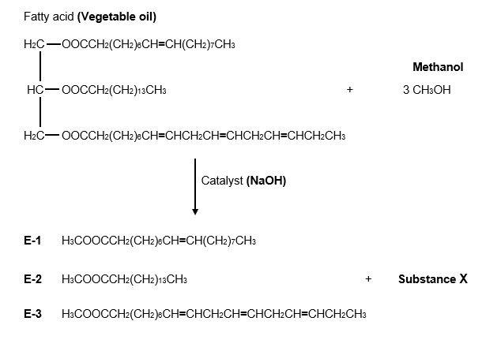

(a) Explain why the vegetable oil above is described as an **unsaturated** oil. (1 mark)

______________________________________________________________________________________________________________________________________________________________________________________________________________________________

(b) As well as the three methyl esters (the biodiesel), there is one other product of this reaction labelled only as **Substance X**. Name and draw the structural formula of this product. (2 marks)

|  |
| --- |
|  |

**Name** ______________________________________________________

(c) Why is a large excess of methanol used in the reaction? (1 mark)

________________________________________________________________________________________________________________________________________________________________________________________________________________________

1. During a typical production run for this synthesis reaction, 1.75 tonnes of the vegetable oil is used. Calculate the minimum mass of methanol that would be required to react with this much oil, given that the vegetable oil used has a molar mass of 855.334 g mol–1.

(1 tonne = 1 x 106 g). (3 marks)

__________________________________________________________________________

________________________________________________________________________________________________________________________________________________________________________________________________________________________________________________________________________________________________________

__________________________________________________________________________

1. As shown on page 26, three different esters, labelled **E-1**, **E-2** and **E-3**, are produced from this reaction. Calculate the mass of ester **E-2** produced in this process, given that the reaction is only 80% efficient during the production of the biodiesel. (4 marks)

__________________________________________________________________________

________________________________________________________________________________________________________________________________________________________________________________________________________________________________________________________________________________________________________

__________________________________________________________________________

__________________________________________________________________________

________________________________________________________________________________________________________________________________________________________________________________________________________________________________________________________________________________________________________

__________________________________________________________________________

1. As stated earlier, esters are also produced when a carboxylic acid reacts with an alcohol. Draw the structure of the carboxylic acid that would be needed to produce ester **E-2** in the reaction above. (1 mark)

|  |
| --- |
|  |

**Question 37 (18 marks)**

Soaps and detergents are common organic substances widely used in our daily lives. While they both consist of a relatively long hydrocarbon chain which is attached to a ‘polar end’, there are also significant differences between the two substances, particularly in their applications as cleaning agents.

A typical soap like sodium stearate, (CH3(CH­2)16COO– Na+), which can be produced from a reaction between tristearin and sodium hydroxide, is shown in the partially completed ‘saponification’ reaction below.

O

CH­3(CH2)16C O CH2

O

CH­3(CH2)16C O CH + NaOH

O

CH­3(CH2)16C O CH2

Tristearin

1. Complete and balance the equation above, including any other organic products formed. (3 marks)

The reaction described above takes place at a moderate temperature range between 60-80oC. As the reaction proceeds, heat energy is also released to the surroundings.

1. On the set of axes drawn below, construct and fully label an appropriate enthalpy diagram to represent the saponification process described above. (4 marks)

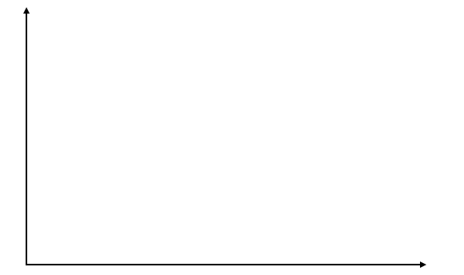

The saponification reaction described on the previous page includes the use of a catalyst. Thus the enthalpy diagram you have drawn above includes the presence of a catalyst.

1. Show on the same diagram that you have already drawn, how the reaction pathway would be different if a suitable catalyst was not used. Label this pathway clearly as the **‘uncatalysed pathway’**. (1 mark)

Soaps and detergents function to remove fats and grease from objects as they clean.

1. Using a simplified general representation of a typical soap or detergent, explain in terms of their structure and polarity, how they are able to achieve their task as cleaners. (6 marks)

____________________________________________________________________________________________________________________________________________________________________________________________________________________________________________________________________________________________________________________________________________________________________________________________________________________________________________________________________________________

________________________________________________________________________________________________________________________________________________________________________________________________________________________________________________________________________________________________________________________________________________________________________________________________________________________________________________________________________________________________________________________________________________________________________________________________________________________________________________________________________________________________________________________________________________________________________________________________________________________________________________________________________________________________________________________________________________________________________

As previously stated, there are some differences between soaps and detergents. One significant difference between a soap and detergent molecule is the limited ability of soap to clean effectively in hard water. The anions of soap molecules form a precipitate called ‘scum’ when they are added to hard water.

1. Using a balanced chemical equation, show why stearate ions, (CH3(CH­2)16COO–), are unable to clean effectively when placed in hard water. (2 marks)

____________________________________________________________________________________________________________________________________________________________________________________________________________________________________________________________________________________________________________________________________________________________________________________________________________________________________________________________________________________

1. Explain why detergents, unlike soaps, do not have this limitation in ‘hard water’. (2 marks)

________________________________________________________________________________________________________________________________________________________________________________________________________________________________________________________________________________________________________________________

____________________________________________________________________________________________________________________________________________________________

**Question 38 (17 marks)**

An alkaline version of a typical fuel cell is shown below. It utilises the oxidation of hydrogen gas (H2) and the reduction of oxygen gas (O2). Both reactants are continuously ‘fed into’ the cell during normal operation. The major product from the overall redox reaction is water, (H2O).

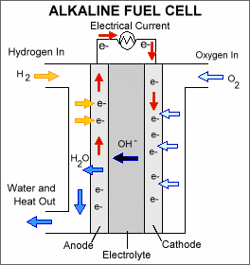

1. During the normal operation of this cell, write the appropriate reactions that will occur:

(i) at the cathode. (1 mark)

________________________________________________________________________

(ii) at the anode. (1 mark)

________________________________________________________________________

(iii) for the cell. (1 mark)

________________________________________________________________________

1. What is the maximum EMF that this fuel cell can generate under standard conditions? (1 mark)

________________________________________________________________________

1. State one advantage and one disadvantage of a typical fuel cell when compared to a dry cell.

(2 marks)

Advantage: ______________________________________________________________

________________________________________________________________________

Disadvantage: ____________________________________________________________

________________________________________________________________________

Another type of electrochemical cell utilises the following standard half-cell reactions.

Cr3+ (aq) + 3e- Cr (s) Eo = - 0.74 V

Cℓ2 (g) + 2e- 2Cℓ – (aq) Eo = +1.36 V

Complete the diagram below to show the construction and operation of this cell. Ensure that you fully label the cell to include:

1. the anode and cathode, including their respective polarities. (2 marks)
2. the electrolytes used. (2 marks)
3. the direction of movement of cations and anions in the salt bridge. (1 mark)
4. the direction of movement of electrons. (1 mark)

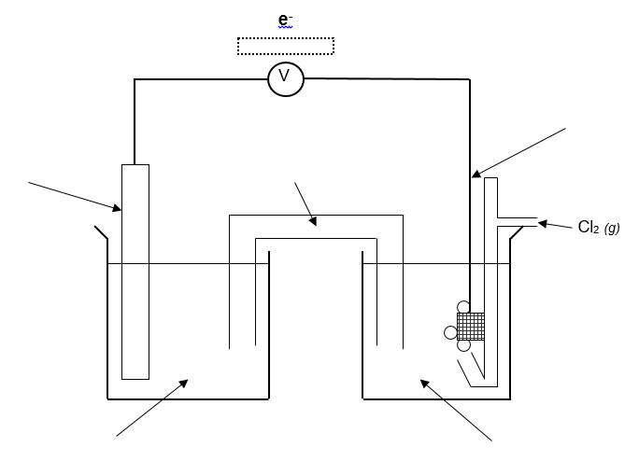

1. Write the overall cell reaction and calculate the cell EMF under standard conditions for this cell. (2 marks)

________________________________________________________________________

Cell EMF = _____________________

1. With reference to the cell you constructed above, and using relevant chemical theory, explain whether a solution of sodium carbonate would be a good choice for use as a salt bridge electrolyte. (Include a balanced chemical equation in your explanation).

(3 marks)

________________________________________________________________________________________________________________________________________________________________________________________________________________________________________________________________________________________________________

__________________________________________________________________________

__________________________________________________________________________

________________________________________________________________________________________________________________________________________________________________________________________________________________________________________________________________________________________________________

__________________________________________________________________________

__________________________________________________________________________

**End of questions**

Spare answer page

Question number: ___________________

________________________________________________________________________________________________________________________________________________________________________________________________________________________________________________________________________________________________________________________________________________________________________________________________________________________________________________________________________________________________________________________________________________________________________________________________________________________________________________

________________________________________________________________________________________________________________________________________________________________________________________________________________________________________________________________________________________________________________________________________________________________________________________________________________________________________________________________________________________________________________________________________________________________________________________________________________________________________________________________________________________________________________________________________________________________________________________________________________________________________________________________________________________________________________________________________________________________________________________________________________________________________________________________________________________________________________________________________________________________________________________________________________________________________________________________________________________________

Spare answer page

Question number: ___________________

________________________________________________________________________________________________________________________________________________________________________________________________________________________________________________________________________________________________________________________________________________________________________________________________________________________________________________________________________________________________________________________________________________________________________________________________________________________________________________

__________________________________________________________________________________________________________________________________________________________________________________________________________________________________________________________________________________________________________________________________________________________________________________________________________________________________________________________________________________________________________________________________________________________________

__________________________________________________________________________________________________________________________________________________________________________________________________________________________________________________________________________________________________________________________________________________________________________________________________________________________________________________________________________________________________________________________________________________________________

________________________________________________________________________________________________________________________________________________

**ACKNOWLEDGEMENTS**

**Section Three**

Question 37 Alkaline Fuel Cell. Sourced from: Public Domain, U.S. Department of Energy [Image].